

**MODERN TOPICS IN INFORMATION TECHNOLOGY**

Assignment Report

MTIT-062

Assignment 03 - Augmented Reality Assignment

Bachelor of Science Special (honors)

In Information Technology

Department of Information Technology

Sri Lanka Institute of Information Technology

Sri Lanka

March 2020

# Declaration

We declare that this is our own work and this proposal does not incorporate without acknowledgement any material previously submitted for a degree or diploma in any

other university or Institute of higher learning and to the best of our knowledge and belief it does not contain any material previously published or written by another person except where the acknowledgement is made in the text.

|  |  |
| --- | --- |
| Name | Student ID |
| O R M Niranthaka | IT17048088 |
| M T I Mohotti | IT17012584 |
| N H Serasinghe | IT16003606 |
| S G J Gallage | IT17055154 |

The above candidates are carrying out research for the undergraduate Dissertation under my supervision.

02/04/2020

…………………………… ……………………………

Signature of the supervisor Date

# Table of Content

Contents

Declaration 2

1. Table of Content 3

2. Introduction 4

**3. Methodology** 5

3.1 Setup the server 5

3.1.1 Step 01 – Creating a web server 5

3.1.2 Step 02 – Creating combined project in the folder 6

3.1.3 Step 03 – Code 7

3.1.4 Step 04 – Run the server 9

**4. Individual Application** 10

4.1.1 IT17012584- M.T.I.Mohotti 12

4.1.2 IT17048088- O R M Niranthaka 13

4.1.3 IT16003606 - N H Serasinghe 14

4.1.4 IT17055154 - S G J Gallage 15

**5. Final Application and Code** 16

**5. Real-life problem** 19

# Introduction

Augmented Reality (AR) makes the real-life environment around us into a digital interface by putting virtual objects in real-time. Augmented Reality uses the existing environment and overlays new information on the top of it unlike virtual reality, which creates a totally artificial environment. Augmented Reality can be seen through a variety of experiences. Recent developments have made this technology accessible using a smartphone which led to development of wide variety of augmented reality apps.

Augmented Reality Apps are software applications which merge the digital visual content into the user’s real-world environment. There are various uses of AR software like training, work and consumer applications in various industries including public safety, healthcare, tourism, gas and oil, and marketing.

For this assignment we are going to develop and AR application for promotion of a Museum. For that we are use four different markers and render four different artifacts on the screen.

# **3. Methodology**

## 3.1 Setup the server

### 3.1.1 Step 01 – Creating a web server

Firstly, we are going to deploy a local web server to host and AR application. And we need a secure web server to host it.

It will access the camera of our mobile phone.

Install the server - npm install -g local-web-server

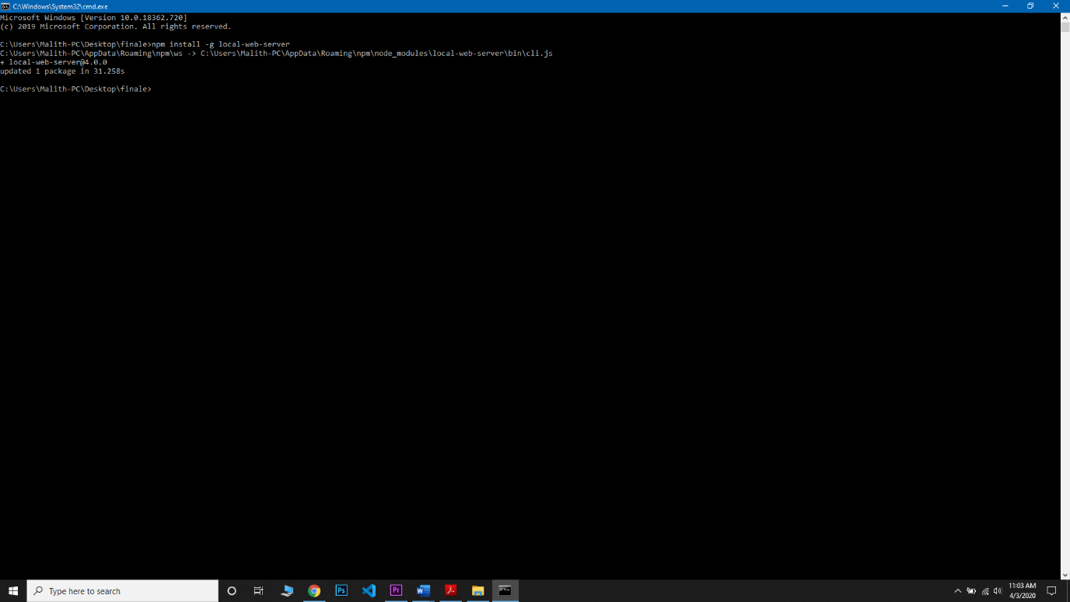

### 3.1.2 Step 02 – Creating combined project in the folder

After crating the server, create a project folder and create a text document and save it as HTML format.html coded in index.html file.

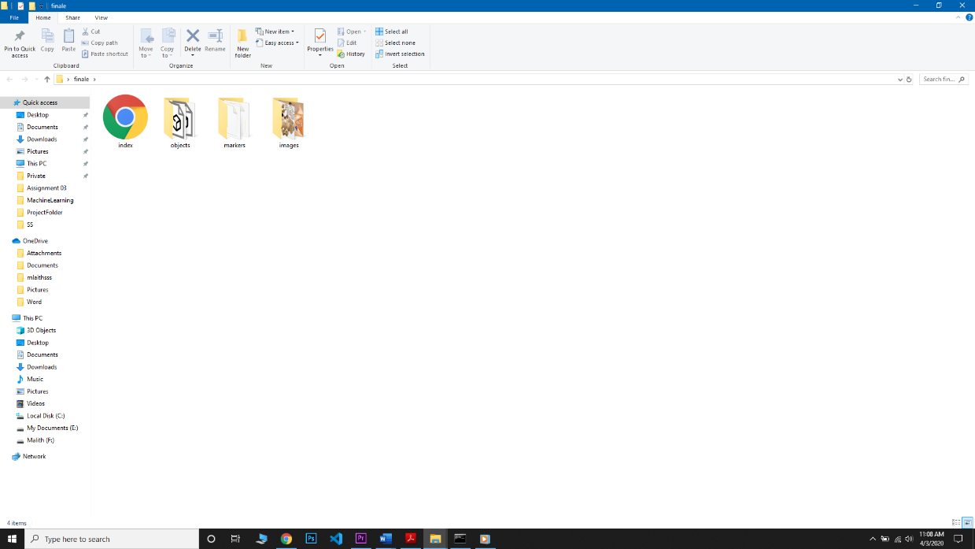

### 3.1.3 Step 03 – Code

<!DOCTYPE html>

<html>

<head>

<!-- include A-Frame obviously -->

<script src="https://aframe.io/releases/0.7.1/aframe.min.js"></script>

<!-- include ar.js **for** A-Frame -->

<script src="https://jeromeetienne.github.io/AR.js/aframe/build/aframe-ar.js"></script>

</head>

<body style='margin : 0px; overflow: hidden;'>

<a-scene embedded arjs>

<a-assets>

<a-asset-item id="tree-obj1" src="objects/1.obj"></a-asset-item>

</a-assets>

<a-marker type="pattern" url="markers/pattern-statue_diffuse.patt">

<a-text value="O R M Niranthaka" rotation="-90 0 0" position="-1 0 1.5" scale="1 1 1"></a-text>

<a-text value=" IT17048088" rotation="-90 0 0" position="-1 0 2" scale="1 1 1"></a-text>

<a-entity obj-model="obj: #tree-obj1;" material="src: images/statue_diffuse.jpg" position="0 0 0"

rotation="-90 0 0" scale="0.01 0.01 0.01">

</a-entity>

</a-entity>

</a-marker>

<a-entity camera></a-entity>

<a-assets>

<a-asset-item id="tree-obj2" src="objects/2.obj"></a-asset-item>

</a-assets>

<a-marker type="pattern" url="markers/pattern-Skull.patt">

<a-text value="N H Serasinghe" rotation="-90 0 0" position="-1 0 1.5" scale="1 1 1"></a-text>

<a-text value=" IT16003606" rotation="-90 0 0" position="-1 0 2" scale="1 1 1"></a-text>

<a-entity obj-model="obj: #tree-obj2;" material="src: images/Skull.jpg" position="0 0 0"

rotation="-90 0 0" scale="0.05 0.05 0.05">

</a-entity>

</a-entity>

</a-marker>

<a-entity camera></a-entity>

<a-assets>

<a-asset-item id="tree-obj3" src="objects/3.obj"></a-asset-item>

</a-assets>

<a-marker type="pattern" url="markers/pattern-13550_Gatto_Rombi_Mask_v1_diff.patt">

<a-text value="M T I Mohotti" rotation="-90 0 0" position="-1 0 1.5" scale="1 1 1"></a-text>

<a-text value=" IT17012584" rotation="-90 0 0" position="-1 0 2" scale="1 1 1"></a-text>

<a-entity obj-model="obj: #tree-obj3;" material="src: images/13550_Gatto_Rombi_Mask_v1_diff.jpg" position="0 0 0"

rotation="-90 0 0" scale="0.08 0.08 0.08">

</a-entity>

</a-entity>

</a-marker>

<a-entity camera></a-entity>

<a-assets>

<a-asset-item id="tree-obj4" src="objects/4.obj"></a-asset-item>

</a-assets>

<a-marker type="pattern" url="markers/pattern-Ancient_jar_diffuse.patt">

<a-text value="S J Gallage" rotation="-90 0 0" position="-1 0 1.5" scale="1 1 1"></a-text>

<a-text value="IT17055154" rotation="-90 0 0" position="-1 0 2" scale="1 1 1"></a-text>

<a-entity obj-model="obj: #tree-obj4;" material="src: images/Ancient_jar_diffuse.jpg" position="0 0 0"

rotation="-90 0 0" scale="0.03 0.03 0.03">

</a-entity>

</a-entity>

</a-marker>

<a-entity camera></a-entity>

</a-scene>

</body>

</html>

### 3.1.4 Step 04 – Run the server

Navigate to the project folder and open the terminal at that location and run the following command.

ws --https

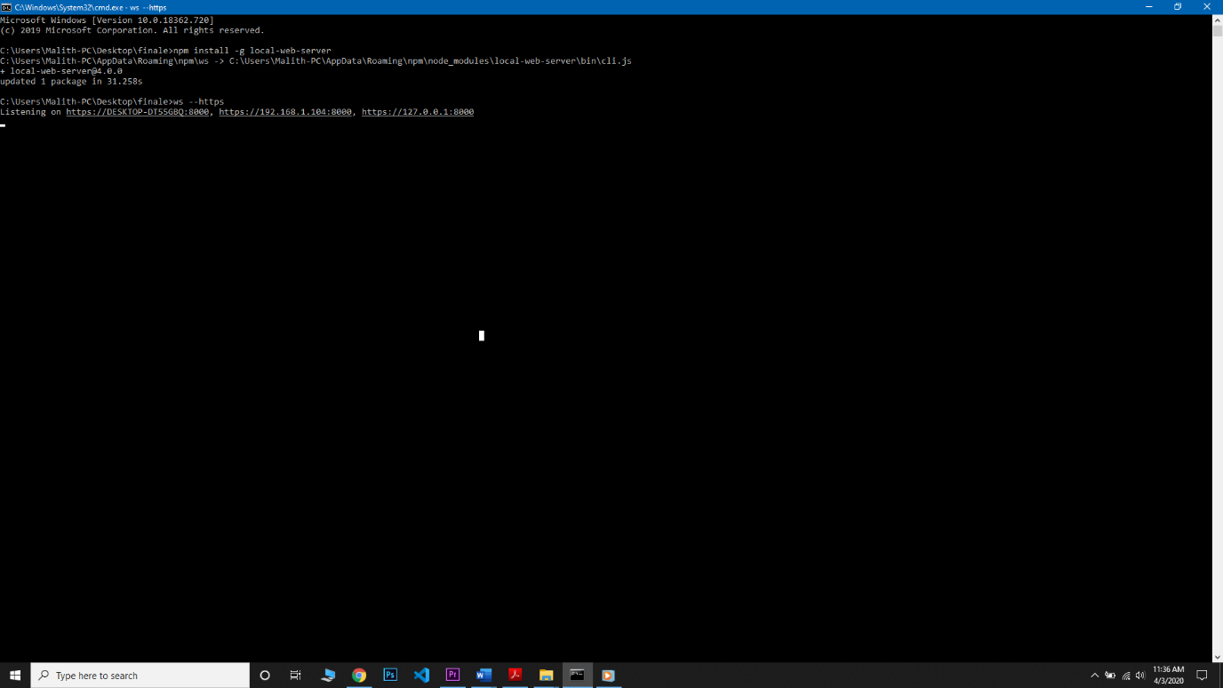

# **4. Individual Application**

Those are the textures that we have selected.

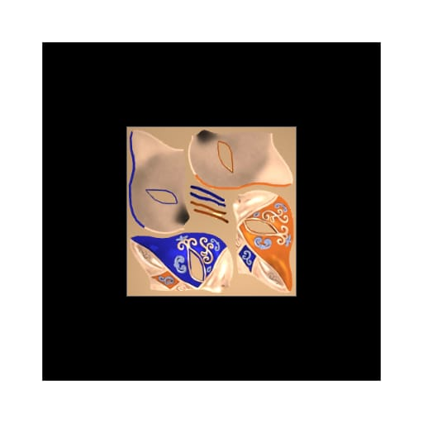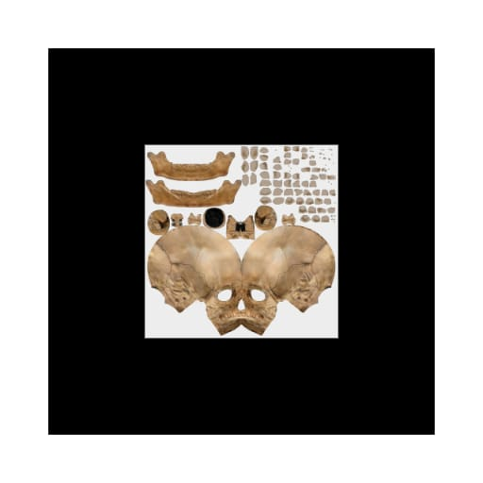

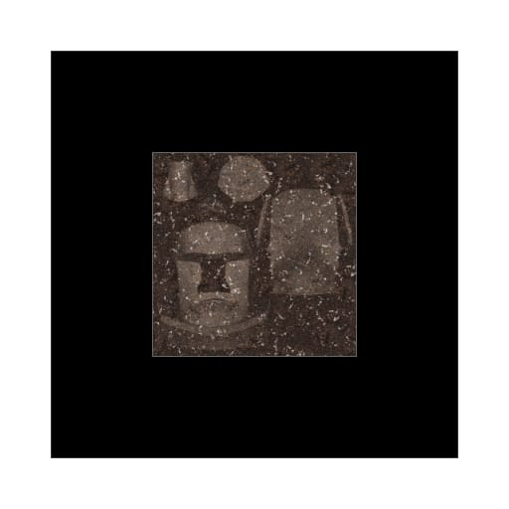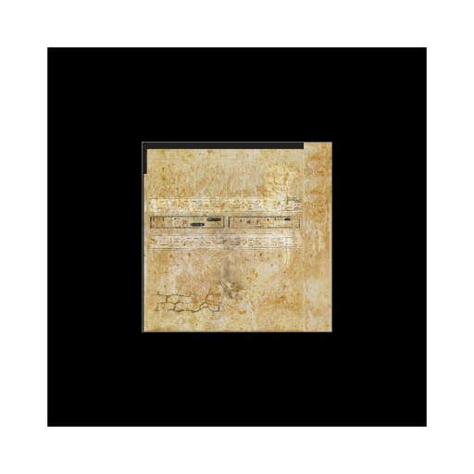

### 4.1.1 IT17012584- M.T.I.Mohotti

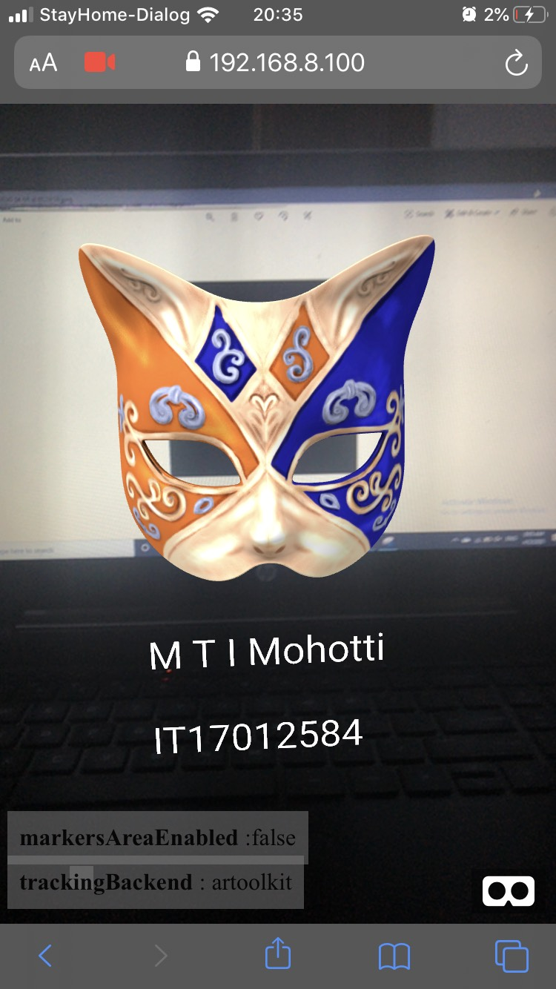

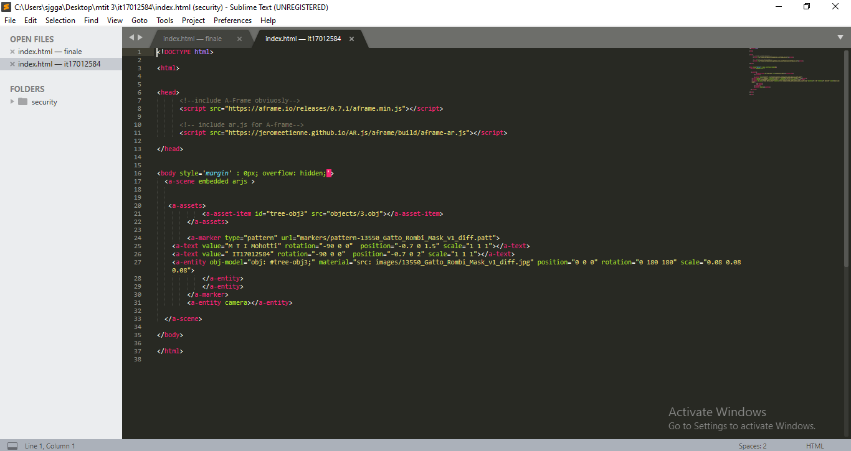

### 4.1.2 IT17048088- O R M Niranthaka

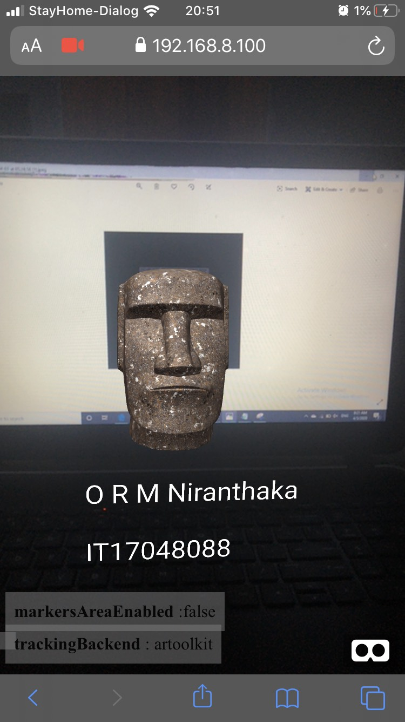

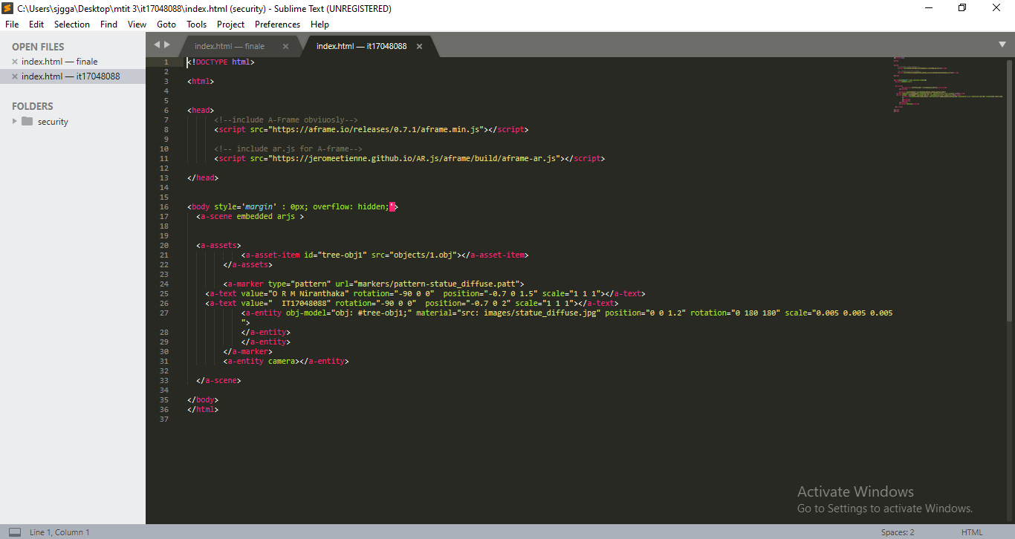

### 4.1.3 IT16003606 - N H Serasinghe

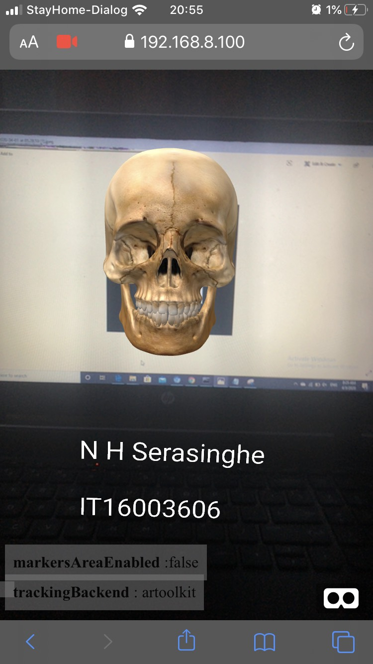

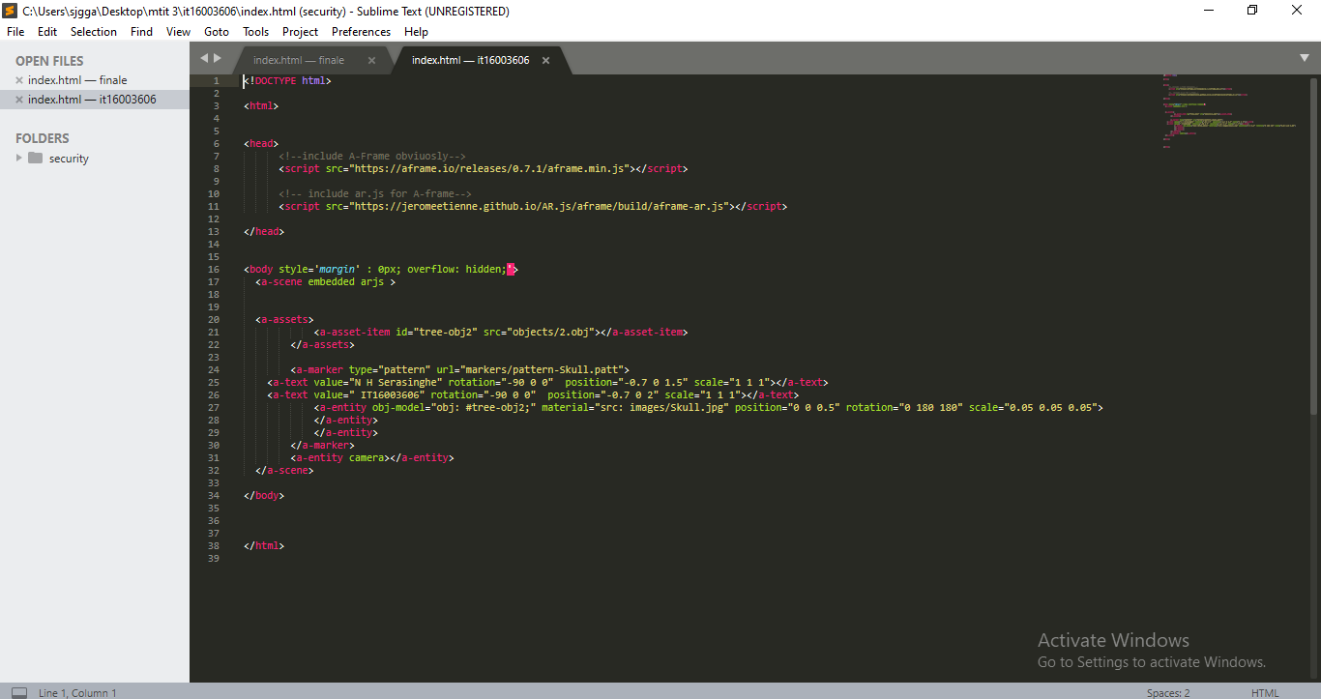

### 4.1.4 IT17055154 - S G J Gallage

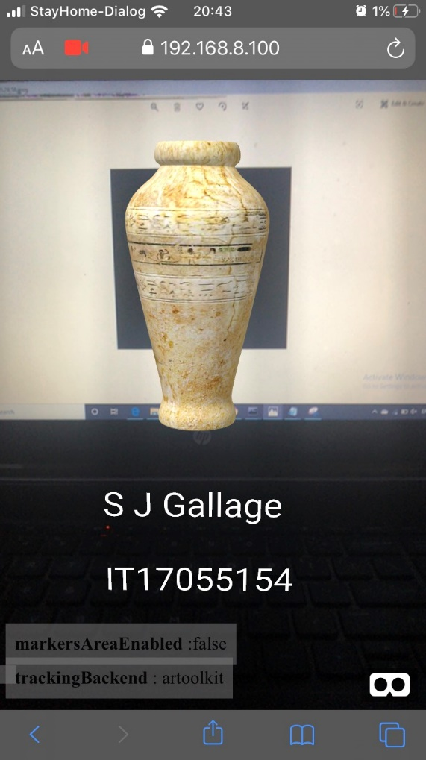

# 

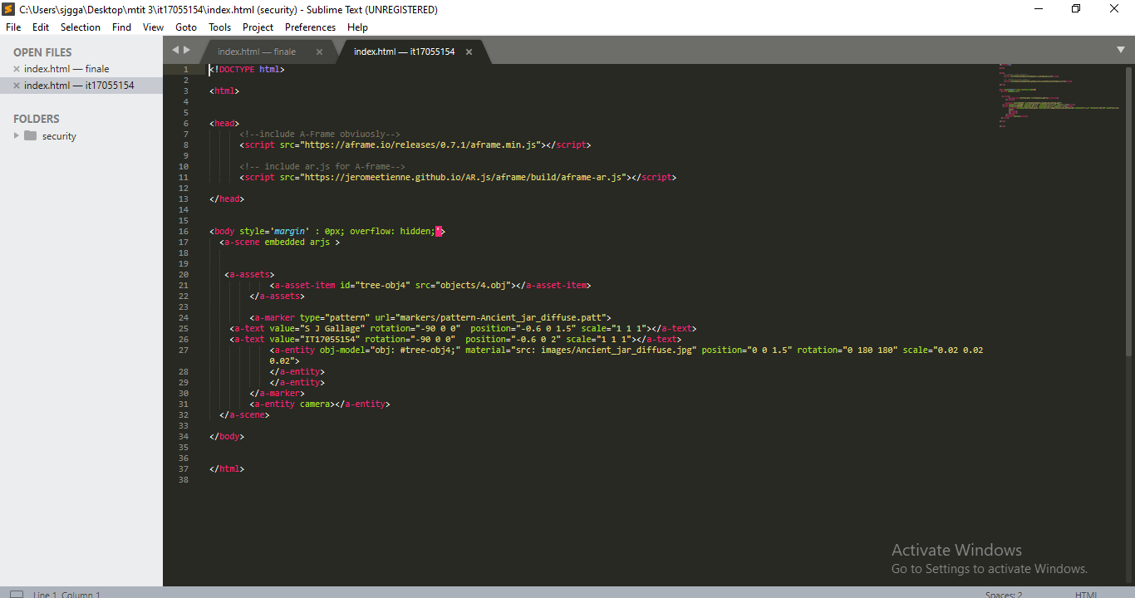

# **5. Final Application and Code**

Side View of the AR application

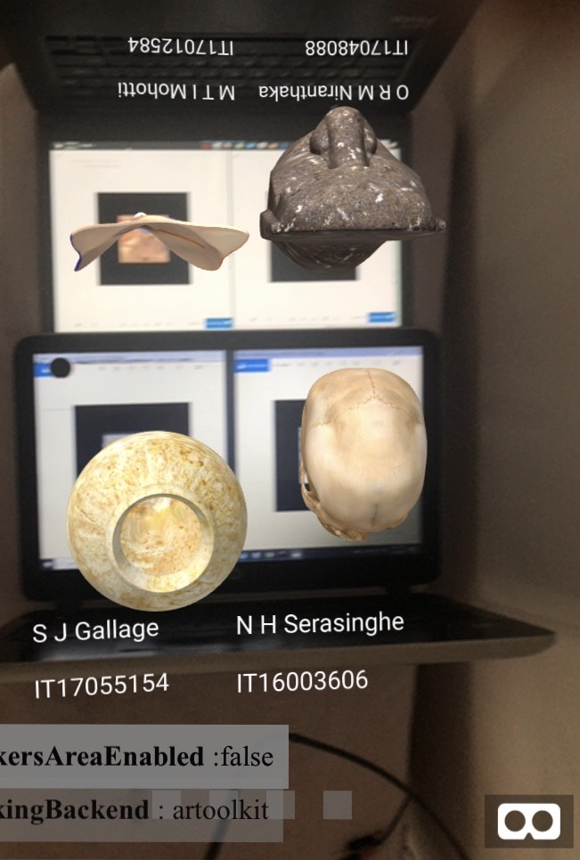

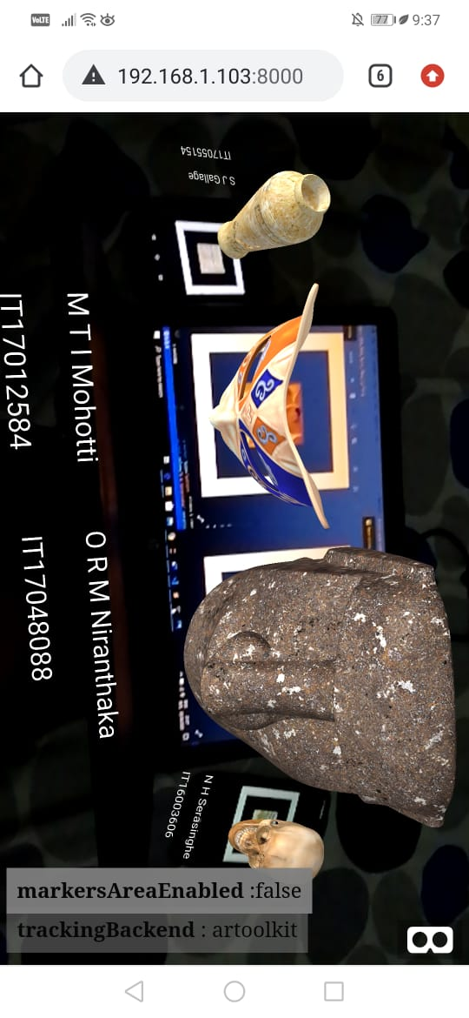

# 

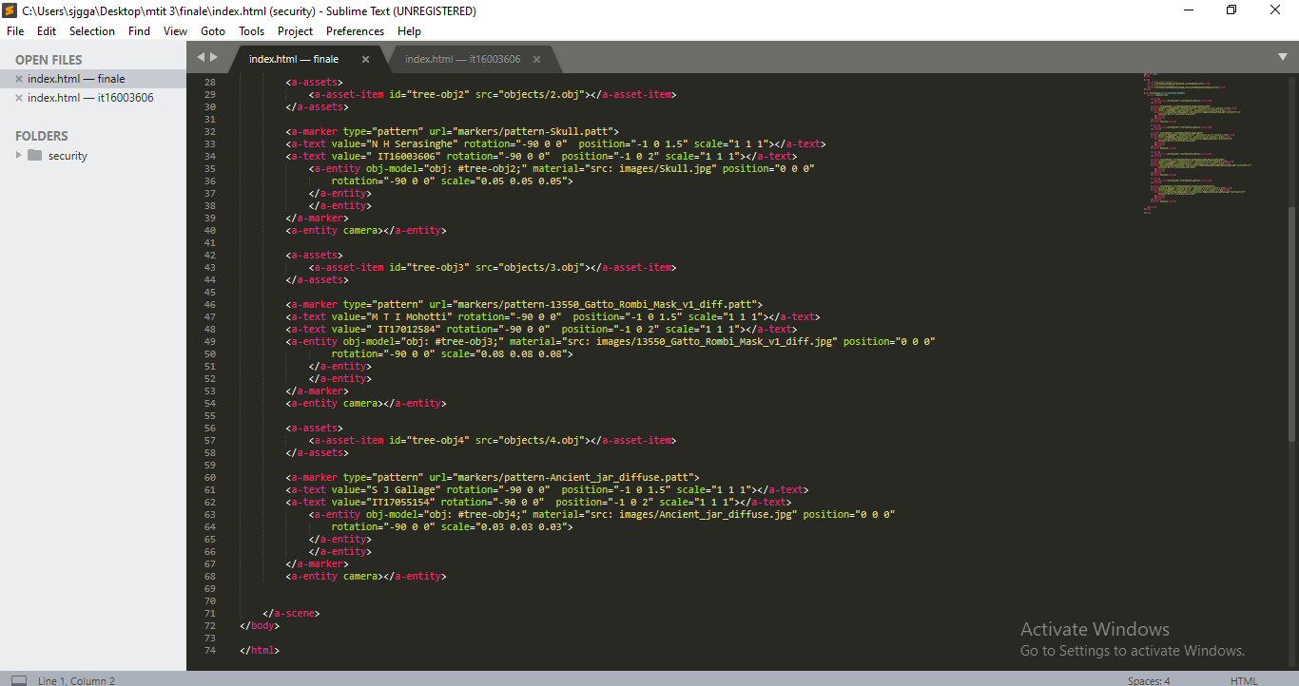

# **5. Real-life problem**

We present our concept of an indoor assistance and navigation system for pedestrians that leverages projector phones. Digitally enhanced guides have many advantages over traditional paper-based indoor guides, most of all that they can be aware of their current context and display dynamic information. That is why particularly shopping malls recently started deploying indoor assistance applications for mobile phones, which also include support for navigation.

Navigation has been a popular area of research in both academia and industry. Combined with maps, and different localization technologies, navigation systems have become robust and more usable. By combining navigation with augmented reality, it can be improved further to become realistic and user friendly.

Moreover, as we show in the paper, projected interfaces offer additional distinct advantages over static guides and even traditional or augmented reality mobile applications. We describe five concepts for a shopping mall indoor assistance system based on projector phones, comprising a support for shop selection, precise wayfinding, "virtual fitting" of clothes, and context-aware and ambient advertisements. We then apply the concepts to a typical shopping scenario, where users wear the phone at their belt and constantly project the interface in front of them. The expected benefits of our system are that people ought to find their way quicker and easier, being less distracted from their usual shopping experience.

